Czech University of Life Sciences Prague

Faculty Of Econmics and Managment
Business Administration

scientific reseach.
Computer Security
Student.
Ahmed Atef Ahmed
EMAIL. XAHMA004@studnti.czu.cz
Professor.

Ulman Milaš
2/11/2021
Table of contents
1. What is computer security? 3
2. Confidentiality 3
3. Integrity 3
4. Availability 4
5. Malware 4
5.1. Viruses 5
5.2. Worms 5
6. Weakness, threat and risk 5
7. Encryption 6
8. Firewall 7
9. Intrusion Detection Systems 8
10. Preventive Measures 8
11. Security Polices 9
11.1. public policies 9
11.2. server policy 9
11.3. firewall access policy 10
11.4. VPN Policies 10
11.5. permissive policy 10
11.6. wise policy 10
11.7. User acceptance policy 10
11.8. Information Protection Policy 11
11.9. Remote access policy 11
11.10. Network policy 11
11.11. Program Security Policy 11
11.12. Email Usage Policy 11
12. Conclusion 12
13. Resources and References 12

Figure 1 A revision of the CIA triad 3
Figure 2 Virus Malware 4
Figure 3 Encryption and Decryption 6
Figure 4 Firewall Deployment 7
Figure 5 IDS 8

What is computer security?
Computer security is the practice of preserving computers and information Stored on their computers free of malware or unauthorized access It is the science that works to provide protection for information from the risks that threaten it by providing the necessary services and means to protect information from internal or external risks They are the measures taken to prevent the access of information to unauthorized persons through communications to ensure the authenticity and authenticity of these communications.

Confidentiality
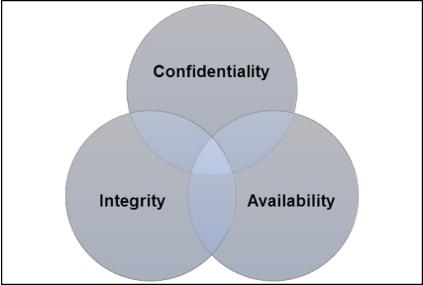
Confidentiality is a fundamental principle of information security that enables its roots in the military loft represented in maintaining from top to bottom power and control over those who have access to information and that confidentiality means the concept of data security. Formalism System-based trust is defined as an individual's perception of the system's ability to meet a set of requirements that will lead that individual to believe that the system can be trusted to perform certain tasks that affect trust, confidentiality, integrity, and the goal of information safety and protection.
Figure 1 A revision of the CIA triad

Integrity
The concept of integrity is related to the concept of ethical integrity in information security and the audit profession, and ethics involves adherence to generally accepted principles and values as well as some rules of conduct with regard to information security and computer security is one of the ways to defend against unethical behavior and defines integrity as prevention. Inappropriately modifying or destroying information, including in particular the validity of the information and non-repudiation
Authenticity and non-repudiation are two safe and closely related terms that are more specific. Authenticity does not guarantee non-repudiation, but non-repudiation guarantees authenticity.

Availability
Availability which means “value” in information security and the term availability means “reliable and timely access and use of information”
A system is considered usable when it is effective and you use it generally satisfied with its performance of specific tasks in a given environment in the case of security software. Offers a balanced approach to ultimately improve security and usability.

Malware
Malware has had a massive impact on the world as we know it. The increasing number of computer security incidents since (1988) indicates that malware is an epidemic.
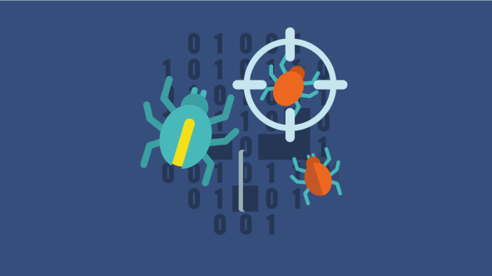
Malware can lead to consequences ranging from defacement of a website to loss of human life
There are many malicious programs that can destroy your device and your information
Figure 2 Virus Malware
- Virus: is a code formed by inserting itself into other programs
- Worms: A computer worm replicates itself by executing its code independently of any other program
The worm is more dangerous than viruses because it is spread across network connections to infect the largest possible number of people, and there are many malicious software such as (Sarwad horses - McGraw - Morrist............)

Viruses
Viruses are small pieces of code that have been inserted into computer files “often with malicious intent.” An infected file may cause data loss. Any file downloaded from the Internet is a vector replaced by viruses. Determine virus-infected files on your computer before activating or copying them. Anti-virus programs work like the body's immune system.

Worms
The computer cycle represents a global threat to the safety of the Internet. It is a self-replicating malware that spreads between computers through a network connection. The computer cycle causes damage to the network by deleting host system files, file encryption, and file encryption in ransomware attack and network security threats. It launches the most destructive attacks in the world. Over time, fully automation makes their behavior repetitive and predictable and spreads across networks while exploiting vulnerabilities in operating systems or installed software.

Weakness, threat and risk
Vulnerabilities are a weakness in a computer system or a configuration error
Threat is the intent to harm the system, and the risk to the owner or administrator of the system is the possibility that the system will not also be able to enforce its security policy.
Risk is a function of both the exposure of the system to vulnerabilities in the context of its security architecture and the level of threat that manifests against the system at a particular time. In this way, its risks can change over time even though the organization's system and operations have not changed at all, as well as the release of information about Race an undisclosed vulnerability in a part of the program that uses the system and even more so the issuance of a script that makes exploiting the vulnerability easy and privileges within their computer systems where no one can authorize a large financial transaction Of course in some cases it is difficult to distinguish between adopting a management strategy Risks and what one can do.

Encryption
The process of converting the simple plain text into a secret text called the ciphertext, and the conversion returns the ciphertext to its original simple text as shown in Figure 3. The process uses algorithms known as cipher algorithms to perform the encryption and decryption process.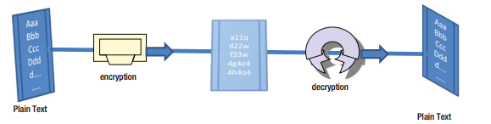
Figure 3 Encryption and Decryption
Encryption and decoding. Sometimes two separate keys are used, one for encryption and the other for decryption
Encryption makes web transactions more secure through digital certificates, 3D security, and more
Encryption is primarily used to protect the confidentiality of data, however it is limited to confidentiality and is used to verify integrity and authentication processes
Encryption is also used to organize access to your total or satellite TV. It is centrally controlled and channels can be accessed. All other signals are mixed using encryption.
Cryptography, cipher analysis, and cryptography are interrelated. General cipher refers to the plain text encryption and decryption technique. Cryptanalysis refers to the analysis and breaking of keys used for encryption and decryption (generally used by hackers) Cryptography refers to both the study of cryptography and cipher analysis.

Firewall
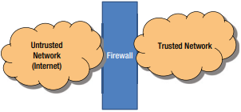
A firewall is designed to prevent damage to your system. These programs or devices work by recognizing the system and allowing only bypass those recognized as good or trusted and to stop unauthorized people from accessing the network and its services from other networks.
Figure 4 Firewall Deployment
It acts as a security guard that usually sits at the main gate and verifies your identity and access privileges and allows you to enter depending on the type of organization and the firewall classifies three basic functions
- Packet rating:- The firewall classifies IP packets.
- Case Packet Anatomy:- Here it bypasses this basic packet filtering and follows the state of the communication flows for all packets. It also keeps track of all currently connected IP addresses at any time.
- Application level portals:- The firewall is also forced to check the implementation level of the protocols. This requires that the firewall understand some specific application protocols.

Intrusion Detection Systems
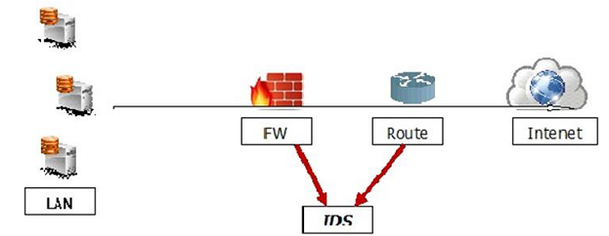
Figure 5 IDS
Intrusion detection systems are also as important as the firewall because it helps to discover the type of attack that is being done on the system and then find to prevent it. It also helps the network administrator to verify the integrity of the connection and the friendships that occur.

Preventive Measures
Most computer experts come up with some simple steps to avoid getting malware
- Software update. Software update fixes critical software vulnerabilities and is essential for a safe and secure device.
- Antivirus software. Antivirus software constantly scans your computer for malicious code and removes it when it is found and removes any programs that behave suspiciously even if the program is not a known type of malware.
To further increase security, users should use strong and unique passwords whenever possible because these programs operate on a single password defined by users and users should make guessing it as difficult as possible and users should be very careful when opening emails from senders Unknown and unexpected email attachments should never be opened.

Security Polices
Protection with security policies is a protection that can reduce the risks of hacking, information leakage, and misuse of the Internet. It also ensures the protection of bad or virus-infected device resources. The IT policies are designed for the information technology department to secure the procedures and functions of the information technology fields.

public policies
This is the policy that defines the rights of users and the level of access to systems in general is even included in the communication protocol as a precaution in the event of any disasters.

server policy
This specifies who should have access to the specific server, what rights to install, what level of Internet access, and how they should be updated.

firewall access policy
Specify who should have access to the firewall and what type of access such as monitoring, ports, and services should be incoming or outgoing.

VPN Policies
These policies are generally consistent with the firewall policy. They specify which users should have access to the VPN and what rights for site-to-site connections with partners. They specify the level of partner access to your network and the type of encryption to set.

permissive policy
It is a policy where the administrator blocks some known malware ports in connection with internet access and only certain exploits are taken into account.

wise policy
This is a policy where everything regarding internet access is blocked and only a small list of websites is allowed and now additional services are allowed to be installed in computers and logs are kept for each user.

User acceptance policy
This policy regulates the behavior of users towards a system, network, or even a web page, so it is explicitly said what the user can do and what cannot be done in the system, such as whether he is allowed to share access tokens and whether they can share resources.

Information Protection Policy
This policy aims to regulate access to information, the processing of hot information, how it is stored and how it is transmitted.

Remote access policy
This policy is for large companies where the user and their subsidiaries are outside their head office. It tells what users have to access, when they can work and on which software like SSH, VPN and RDP

Network policy
This policy is intended to restrict anyone's access to the network resource and to clarify who will access the network. It will also ensure whether or not this person should be authenticated. This policy also includes other aspects such as, Who will authorize the new devices to be connected to the network? Documenting network changes. Web filters and access levels. Who should have a wireless connection, authentication type, and connection session validity.

Program Security Policy
This policy relates to what software is installed on the user's computer and what should be on it. Only whitelist software should be allowed. No other software should be installed on the computer. Warez and malware should not be used.

Email Usage Policy
This is one of the most important policies to do because many users use business email for personal purposes as well. As a result, information can leak out. Some of the main points of this policy are that users should know the importance of this system which they are privileged to use. They should not open any attachments that look suspicious. Private and confidential data must not be sent via any encrypted email.

Conclusion
This is how I came to the conclusion after detailing information security. In the research, methods of protecting data and information, types of threats to information security and how to preserve personal data were presented. If the world opened up to each other, the privacy of data must be preserved, especially since it has become data for it. A lot of importance such as bank account numbers and other personal data and so on.

Resources and References
- Computer Security. By: Biscontini, Tyler, Salem Press Encyclopedia of Science, 2019
- Moore, D., Shannon, C., Voelker, G.M., Savage, S.: Requirements for containing self-propagating code. IEEE Internet Quar. 3(18), 1901–1919 (2003)
- https://library.oapen.org/bitstream/handle/20.500.12657/28165/1001829.pdf?sequence=1
- David Coss Virginia State University, USA http://www.proso.com/dl/Samonas.pdf
- Stafford, Thomas F. and Urbaczewski, Andrew (2004) "Spyware: The Ghost in the Machine," The Communications of the Association for Information Systems: Vol. 14, Article 49. Available at: http://aisel.aisnet.org/cais/vol14/iss1/49
- F. Castaneda, E. C. Sezer, and J. Xu. Worm vs. worm: preliminary study of an active counter-attack mechanism. Proceedings of the 2004 ACM Workshop on Rapid Malcode, 2004.
- https://link.springer.com/article/10.1007/s102070100003
- Carl E. Landwehr Mitretek Systems, 7525 Colshire Drive, McLean, VA 22102, USA, USA

